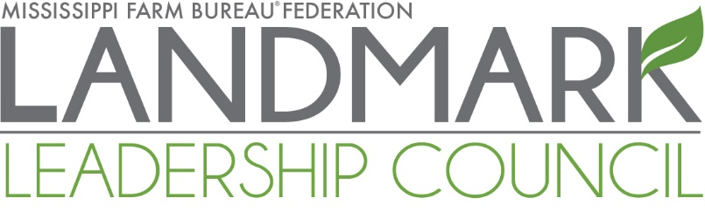

Inaugural Meeting
June 23-24, 2023
The Mill Conference Center – Starkville, MS

FRIDAY, JUNE 23:

Lunch on Your Own

11:00 a.m. Registration Table Open
The Mill Foyer – 600 Russell Street, Starkville

1:30 p.m. General Session
The Mill – Mississippian Ballroom

1:30 p.m. Opening Remarks
Mike McCormick, MFBF President
Donald Gant, MFBF North MS Vice President
Ted Kendall, MFBF Central MS Vice President
Jeff Easterling, MFBF South MS Vice President

2:00 p.m. Landmark Leadership Council: Program Overview and Vision for the Future
Samantha Laird, MFBF Leadership Development Coordinator

2:30 p.m. Family Business Workshop: Farm Management and Longevity
Jolene Brown, Iowa Row Crop Farmer and Professional Speaker

4:30 p.m. Hotel Check-In
Courtyard by Marriott – 100 Mercantile Street, Starkville
Comfort Suites – 801 Russell Street, Starkville
La Quinta Inn & Suites – 982 Highway 12 East, Starkville
Hilton Garden Inn – 975 Highway 12, Starkville

6:30 p.m. Optional MFBF F.A.R.M. Fund PAC Fundraiser Dinner – TICKETS REQUIRED
Mississippi State University Hunter Henry Center
Entertainment by Chris Boykin

To purchase tickets, please visit: www.bidpal.net/LLCpac

SATURDAY, JUNE 24:

7:30 a.m. Breakfast
The Mill – Mississippian Ballroom

8:00 a.m. Sponsor Spotlight
Mississippi Land Bank

8:20 a.m. Engagement and Advocacy Training: Seven Actions of Highly Effective Advocates
Roger Rickard, Founder & President, Voices in Advocacy

9:30 a.m. Networking Break
The Mill – Foyer

10:00 a.m. General Session
The Mill – Mississippian Ballroom

10:00 a.m. Key Advisors Panel
Moderator: Jolene Brown, Iowa Row Crop Farmer and Professional Speaker
Panelists:
Attorney – Tyler McCaughn, Senate Forestry Chairman, Attorney, & Cattle Farmer
Accountant – Dave Clarke, Certified Public Accountant, Bridgers CPAs
Financial Advisor – Chris Cole, Vice President and Financial Advisor, Baird
Lender – Bobby Spinks, Senior Vice President of Lending, Mississippi Land Bank

11:30 a.m. Lunch
The Mill – Mississippian Ballroom

12:10 p.m. Advancing Leadership
Dr. Mark Keenum, President, Mississippi State University - INVITED

12:45 p.m. Networking Break
The Mill – Foyer

1:15 p.m. Closing Session
The Mill – Mississippian Ballroom

1:15 p.m. Group Discussion: Program Questions and Feedback
Facilitated by: Samantha Laird, MFBF Leadership Development Coordinator

2:00 p.m. LLC Participant Form and Survey Completion

2:30 p.m. Closing Comments and Adjournment
Mike McCormick, President, Mississippi Farm Bureau Federation

